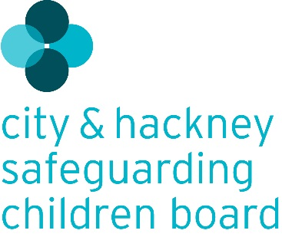

Multi-agency Guide to Chronologies

This guidance is to help all agencies that come into contact with children and young people in fulfilling their responsibility for identifying, evidencing and reporting any concerns they may have. Sometimes events on their own may seem not very significant, but using a chronology can help evidence feeling something is wrong.

This tool may help agencies to decide whether to make a referral to Hackney Children’s Services/ City of London Children Services and may also help practitioners to describe and evidence their concerns so a referral can be responded to appropriately.

This is intended to be an additional tool support to, and not something that would ever stop someone from raising concerns about a child immediately or seeking advice if they are not sure what to do.

What is a chronology?

A chronology is simply a running record of events that may be seen as significant and can help build up a picture of what is happening to a child and describe it to other agencies. Practitioners using this tool should try to keep to the facts of what has happened: what they have seen or heard; when a child displays behaviour that concerns them or if someone (adult or child) tells them something. It might be useful for practitioners to think about when things haven’t happened too, such as families missing appointments.

Practitioners may sometimes feel that things are not right, creating a running list can help reflection on what is worrying them so they can make a decision about what to do. This is the structure:

Date | Event | Any documents that could be shared to help evidence anything e.g. emails  (optional) | Why did this generate concern?  (optional, but may help reflection) | What action has been taken? (your agencies response)
dd/mm/yy

The Hackney Child Wellbeing Framework and the City of London Threshold of Needs have useful descriptions of child and family need and the responses that might best meet those needs.

If you have any immediate concerns, do not wait to contact your safeguarding lead. Or you should contact

Hackney Children’s Services:

- First Access and Screening Team (FAST) 9am-5pm Monday-Friday except Bank Holidays on Tel: 020 8356 5500 Fax: 020 8356 5516 or fast@hackney.gov.uk.
- Outside of these hours, please call 020 8356 2710

City of London Children & Families
- Children services 9am-5pm Monday-Friday except Bank Holidays on Tel: 020 7332 3621
- Outside of these hours, please call 020 8356 2710

When calling it may useful to reflect on:
- Why you are concerned and also what is going well for the family
- What support or services you believe the family need – do they have an allocated social worker you can contact?
- If you have discussed your concerns with the family and their response to this
- What information children services need to make the best decision

Resolving disagreements
In the event of any disagreements arising between partner agencies relating to children services decision-making, this will be dealt with, in the first instance, at local level through discussion with relevant partner team members.

Where a resolution cannot be found at this level within a reasonable timescale, the matter should be referred to the Service Manager or Head of Service, alternatively please refer to the City & Hackney Safeguarding Children’s Board Escalation Policy

