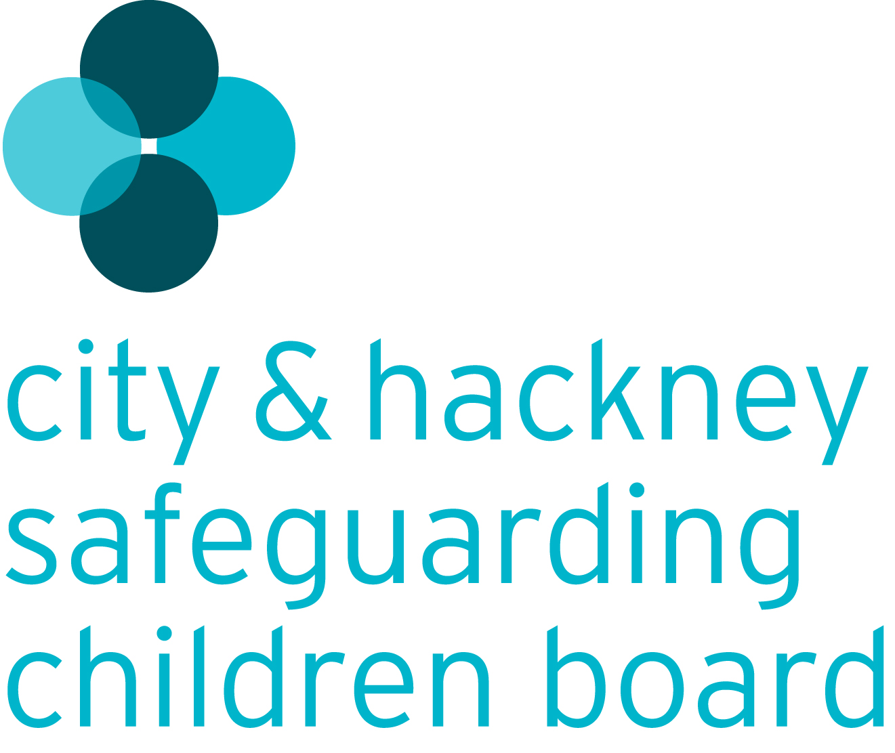

Business Plan 2014-15

“Working Together to make children safer”
Introduction

Whilst we do not underestimate the complexity of the safeguarding system, our vision as the City and Hackney Safeguarding Children Board (CHSCB) is a simple one: Working Together to Make Children Safer

As leaders across a range of organisations, our commitment is to work together to make the lives of children safer by protecting them from harm; preventing impairment to their health and/or development, ensuring they receive safe and effective care; and ensuring a safe and nurturing environment for them to live in.

All the partners on the CHSCB want to make sure that everyone who works with children across the City and Hackney has the protection of vulnerable children and young people at the heart of what they do. Our aim is to ensure our child protection practices and procedures are at least good, and that staff in every agency, at every level, know what they need to do to keep children protected, and communicate effectively to ensure this happens.

Our Principles

All of our activity is underpinned by the following principles:

- Safeguarding is everyone’s responsibility.
- At the core of our safeguarding and child protection work is the commitment to understand the quality of a child’s experience of local services
- To learn from individual experiences and have a positive impact upon young lives
- To champion and protect the safeguarding needs of vulnerable children and young people
- Our work is characterised by an attitude of constructive professional challenge
- To foster a culture of continuous review and learning with evidence based practice
- To foster a single child-centred culture, focussed on the needs of children, young people and their families
- To capitalise on the unique opportunities presented by a dual-borough board.

Our Priorities

This refreshed strategic plan for 2014-15 outlines the key priorities for the CHSCB over the next year. The intention is for this plan to provide a bridge for the CHSCB for the next 12 months. A more robust process of partnership engagement across the City and Hackney will be used in developing the business plan for 2015 onwards.

Over the coming year, the Board will continue to strengthen its governance arrangements between CHSCB members and other partnership Boards and ensure that it provides more effective challenge to the safeguarding system across the City and Hackney.

In order for business planning processes to lead to improvements, the priorities need to be relevant to the local area, be based on local knowledge and have a clear alignment to overall annual reporting processes and future planning. The agreed strategic objectives within this Business Plan are drawn from themes arising over the previous year, referenced in the Annual Report 2012-13. For 2014-15, the CHSCB is targeting three broad priority areas around which its main improvement work will be structured:

- Communication & Engagement
- The Quality of Practice and Service Delivery
- Learning & Improvement

The agreed focus for the Quality of Practice and Service Delivery in respect of multi-agency activity is Early Help, Neglect, Domestic Violence, Child Sexual Exploitation and Child Abuse linked to Faith or Belief. All of these areas are subject to ongoing work by the partnership.

Underpinning all of our priorities, the CHSCB will evidence more direct engagement with children, young people and families and ensure a robust communications and engagement strategy is in place to support this.

Jim Gamble
Independent Chair, CHSCB

PRIORITY 1: COMMUNICATION and ENGAGEMENT
Outcome | Milestone | Lead | Timescale | Progress
Effective communication and engagement helps the CHSCB to understand the experiences of children, young people, families, staff and communities and this directly influences service planning and improvements in practice.  Outcome | A CHSCB Communication and Engagement Strategy is developed and agreed by the Board; with an associated action plan implemented across The City and Hackney.  - The CHSCB operates a programme of structured direct consultation with children, young people and parents/carers in order to inform the work of the CHSCB.  - The CHSCB systematically collates service user feedback from individual agencies to further its understanding of the experiences of children, young people and families – including the most vulnerable  - The CHSCB demonstrates improvements to the outcomes for children receiving child protection services as a consequence of direct engagement with children, young people, families, the community and professionals  - The CHSCB has a strong professional relationship with the local community that continually builds awareness of safeguarding children. The CHSCB is appropriately reactive to issues.  - The CHSCB is represented and creates clear links on all multi-agency partnerships where safeguarding is a focus of their work evidenced through minutes of those meetings and identification of areas of joint work.  - The LSCB communicates with the local workforce and community to raise awareness of safeguarding issues, through the LSCB website, Newsletters, Annual Conference, Annual Report, community partnerships and directly with public. | Comms & Engagement Sub Chair  Lead | Dec 14

PRIORITY 2: Quality of Practice & Service Delivery – EARLY HELP
Outcome | Milestone | Lead | Timescale | Progress
Children and young people receive effective early help when problems arise that meets a range of needs in different communities. | That the CHSCB has undertaken a programme of work to establish assurance that the early help system across City & Hackney is robust and develops an action plan to address any identified areas of improvement. Programme to include:  - The strategy and governance arrangements supporting early help  - The universal early help offer  - The existing early help framework for assessing and responding to needs early.  - The front door response in both City & Hackney and associated threshold documents.  - Communications and multi-agency training regarding early help. | Professional Advisor, CHSCB | Dec 14

PRIORITY 2: Quality of Practice & Service Delivery – NEGLECT
Outcome | Milestone | Lead | Timescale | Progress
The professional network is confident in identifying concerns relating to the neglect of children and young people; an agreed multi-agency response is in place to provide early help where problems are first identified and intervention is successful in improving outcomes, and where this isn’t successful, swift and robust action is taken to safeguard and promote the wellbeing of children and young people. | The CHSCB develop and implement an agreed multi-agency Neglect Strategy covering:  - Awareness and understanding of neglect (link to Hackney Wellbeing Framework)  - Early help assessment and response to cases of neglect  - Professional practice in recognition and referral of neglect cases to Children’s Social Care  - Assessment of neglect – use of tools  - Monitoring and reviewing cases of neglect  - Supporting the workforce | TBC | March 15

PRIORITY 3: Quality of Practice & Service Delivery – CHILD SEXUAL EXPLOITATION
Outcome | Milestone | Lead | Timescale | Progress
That children and young people in the City & Hackney are effectively safeguarded from Child Sexual Exploitation. | The CHSCB strategy in response to Child Sexual Exploitation is developed and agreed by the Board; with the associated CSE action plan implemented across the City and Hackney. | CSE Working Group Chair | Dec 14

PRIORITY 3: Quality of Practice & Service Delivery – DOMESTIC VIOLENCE
Outcome | Milestone | Lead | Timescale | Progress
That the response to the impact of domestic abuse on children and families is responded to effectively across the safeguarding system | That the CHSCB has undertaken a programme of work to establish assurance that the multi-agency response to domestic violence is robust and that children are being effectively safeguarded. | TBC | Dec 14

PRIORITY 3: Quality of Practice & Service Delivery – ABUSE LINKED TO FAITH, BELIEF, HARMFUL PRACTICES
Outcome | Milestone | Lead | Timescale | Progress
Children and young people are protected, communities are engaged, practitioners are empowered, victims and witnesses are supported and key messages are communicated in respect of abuse linked to faith or belief across The City & Hackney. | The local strategy in response to Female Genital Mutilation has been developed and agreed by the CHSCB; with the associated action plan implemented to improve the safeguarding response to this area of abuse.  That the CHSCB has undertaken a programme of work to establish assurance that the multi-agency response to other forms of abuse linked to faith, belief and traditional practices are robust and action plans developed to address any identified areas of improvement | Director of Public Health  Community Partnership Advisor

PRIORITY 4: LEARNING AND IMPROVEMENT
Outcome | Milestone | Lead | Timescale | Progress
Lessons are identified, disseminated embedded and lead to improvements in the quality of safeguarding practice and service delivery | The CHSCB implements a revised Learning and Improvement Framework which promotes different ways of identifying learning about the effectiveness of safeguarding, how lessons are disseminated and embedded and how related learning has influenced practice / service delivery and had positive outcomes on children and young people.  Including:  - The CHSCB maintains 2 multi-agency datasets which supports understanding of the child’s ‘journey’, from early intervention to permanency across the City and Hackney - + maintains datasets regarding specific safeguarding circumstances  - A ‘mapped’ system of feedback from children, young people, families and communities is in place covering both City and Hackney.  - A ‘mapped’ system of feedback from staff is in place covering both City and Hackney to capture front-line intelligence.  - A multi-agency audit and review programme is in place, promoting learning, which encompasses the perspective of the child and the family as well as the practitioner.  - An audit map charting all single agency QA activity in safeguarding within all agencies is developed with scheduled reporting of findings to the CHSCB.  - A Section 11 audit process operates which raises awareness of safeguarding and promotes learning across different agencies.  - Appropriate use of the learning from local and national serious case reviews and multi agency reviews to improve safeguarding. | Learning & Improvement Sub Chair | Sept 14

Key

Lead Person refers to the Chair of each sub committee. They will take responsibility for ensuring that their sub committee delivers the work plan set out below.

Items highlighted in Grey denotes work completed.
Items highlighted in Green denotes action on track.
Items highlighted in Amber denotes action in progress but in need of attention.
Items highlighted in Red denotes action outstanding and requiring urgent attention.

